Revelation 21:9-16
“The Magnificence of the New Jerusalem”

The Gates of New Jerusalem: (v.12)

12 tribes: Dt. 32:6-25 vs. Rev. 7:4-8

The Foundation of New Jerusalem (v.16)

12 apostles of the Lamb: Mt. 10:2-4 (the 12) vs. Acts 1:15-26 (Matthias) vs. 1 Cor. 15:8 (Paul)

The “shape” of New Jerusalem (v.16)

Cube: “Foursquare” (21:16; cf. Ex. 27:1 “Ark”; Eze. 40:47 “Temple”);
“Pyramid”: “The lamb’s wife” (21:2c; 9b)

Psalm 118:22: “Head of the corner” / “Capstone”
Ephesians 2:20: “Cornerstone”
1 Peter 2:6-7: “Cornerstone” (v.6) becomes the “Head of the corner” (v.7)

The “size” of Old Jerusalem

David’s time (1000 BC): .01158 sq. miles: 3 football fields
“Old city” (today): .3363 sq. miles: 87 football fields

The “size” of New Jerusalem

Length, Breadth, and Height:

12,000 furlongs or stadia
Furlong = 582 ft.: 1322.72 miles
Stadia = 607 ft.: 1379.5 miles
Avg. – 1350.5: ** app. 1400 miles

Base of “pyramid” / cube:

1,960,000 sq. miles / 54,641,664,000,000 sq. ft.
1,138,368,000 football fields
379,456,000 times bigger than in 1000 BC

Today’s standards:

1/2 the size of Europe
7.3 times bigger than Texas (268,601 sq. miles)
20 hours to drive across at 70 MPH
*49 hours to ride world’s fastest elevator to the top (Stratosphere)

Volume of “pyramid” / cube:

914,666,666.66 cubic miles / 2,744,000,000 miles
78,986,758,779.5 / 236,960,276,339 times bigger than in 1000 BC
2,719,793,834.9 / 8,159,381,505 times bigger than the “Old City”

Living quarters:

Number of people = 16 billion (“Pyramid” / Cube)
Volume divided by population:

.057 cubic miles / .172 cubic miles
8,390,283,264 cubic ft. / 25,318.047,744 cubit ft.

Today’s standards:

“Benz” Stadium in Atlanta: 610,000,000 cubic ft.
Sears Tower: 73,406,250 cubic feet

Ratio = “Pyramid”: 115 Sears towers or 13.75 “Stadiums” per person
“Cube”: 345 Sears towers or 41.5 “Stadiums” per person

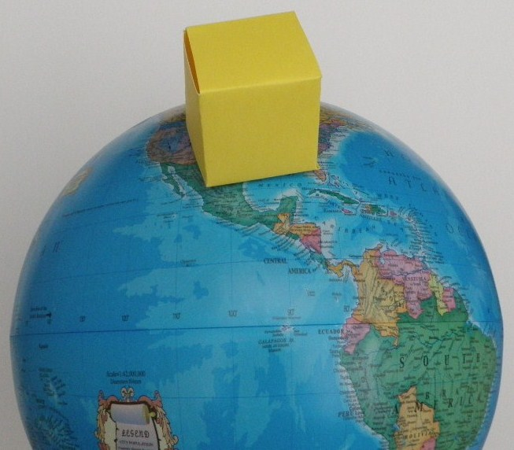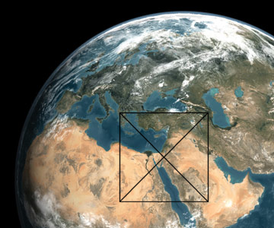

Interesting “observation:

If you are 1 mile away from the city, you would not see the top but might if you are 10 miles away.
At 5,000 miles away, it would appear more than 130 times larger than the moo. To appear the size of the moon you would have to be 160,427 miles away.*

The “size” of New Earth using the same ratios as above

Earth’s surface area:

183,351,902.84 sq. miles / land area = 53,355,403.72 sq. miles

Earth’s volume:

233,457,779,130.57 cubic miles

“Ratios”

David’s city in ratio to New Jerusalem: # 1.8 x 10 to the 22 cubic miles / 5.5 x 10 to the 22 cubic miles
“Old City” in ration to New Jerusalem: # 6.3 x 10 to the 20 cubic miles / 1.9 x 10 to the 21 cubic miles

Using David’s ratio:

“Multiply by 3 to get the ‘Cube’ value”
New earth = 60,000 of our sun which can contain 1.3 million earths
Or 78,000,000,000 times bigger than it is today

Surface area = 1.43 x 10 to the19 sq. miles / 16b = 893,750,000 sq.mi.
Land area = 4.16 x 10 to the 18 sq. miles / 16b = 230,107,593 sq. mi.

The “size” of New Heaven

Current universe (sphere):

30 billion lt. years in diameter = 9.22 x 10 to the 66 cubic miles

“Future” universe (sphere):

7.19 x 10 to the 77 cubic miles

* http://www.tourofheaven.com/eternal/new-jerusalem/size.aspx Accessed June 18, 2019.

